1. SINGLY LINKED LIST

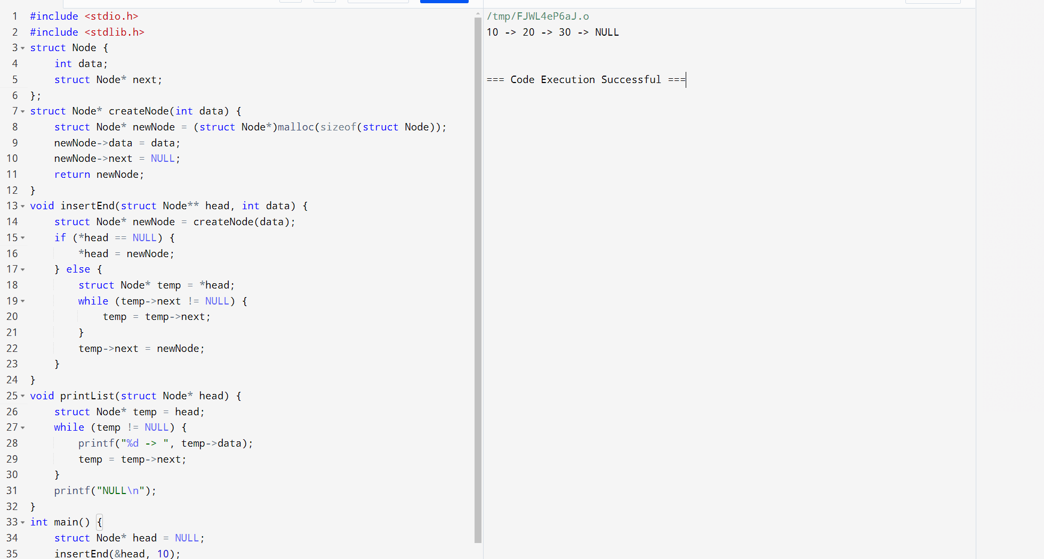

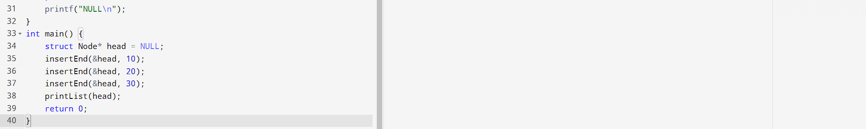

1. DOUBLY LINKED LIST

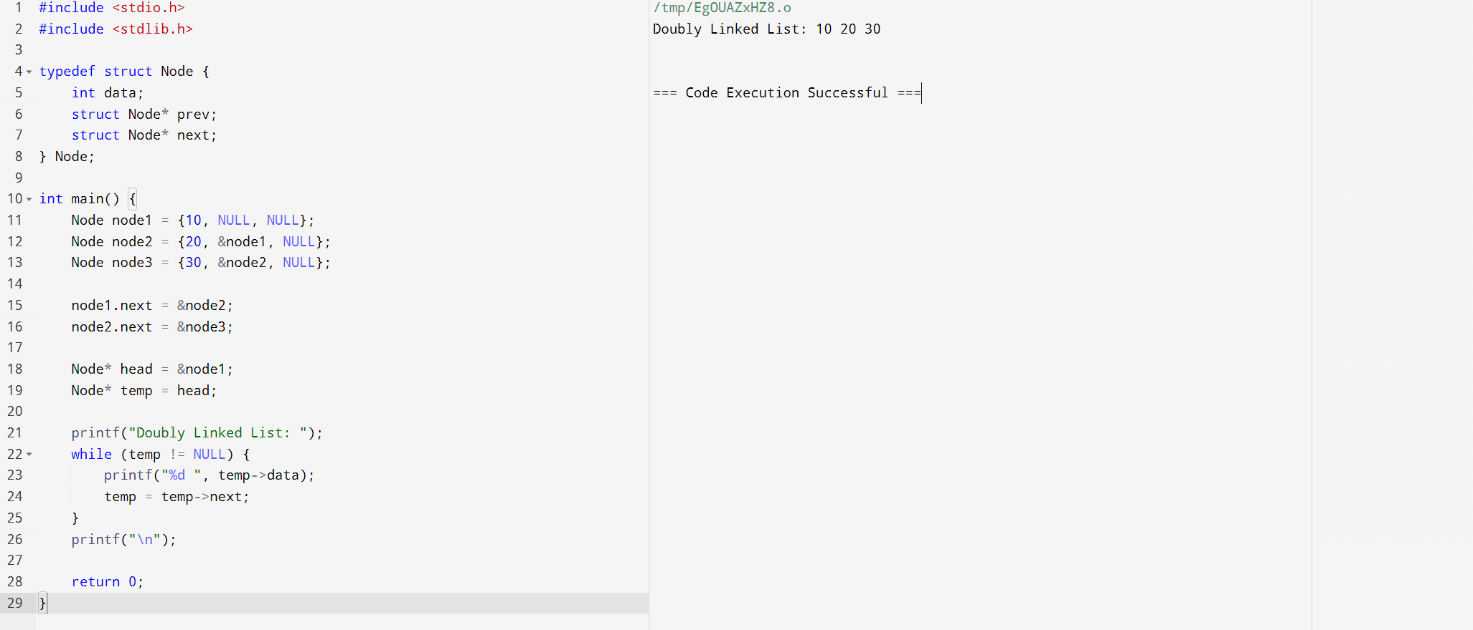

3.CIRCULAR LINKED LIST

